

**Water Tanker Booking System (WTBS)**

**CPIT 498 Final Report**

By

|  |  |
| --- | --- |
| Mohammed Abbas Komo | 1207854 |
| Mansour Fahad Alnowiqi | 1207730 |

Supervised By

[Dr.Mutasem Jarrah]

Department of Information Technology

Faculty of Computing and Information Technology

King Abdul-Aziz University

Jeddah – Saudi Arabia

[1st term/2015-2016]

Contents

1. Chapter 1 6

1.1. Project background. 6

1.2. Problem Definition 6

1.3. Current Situation 7

1.4. Aims 8

1.5. Project objectives 8

1.6. Scope 8

1.7. Suggested Solutions 9

1.8. How will it work? 10

1.9. Flow chart 11

1.10. What the committee will see at the end of our Project? 12

1.11. Key elements: 12

1.12. Project stakeholders: 12

1.13. Feasibility Analysis 13

1.13.1. Objectives of a feasibility study: 13

1.13.2. Types of feasibility 13

1.13.2.1. Technical feasibility 13

1.13.2.2. Economic feasibility 13

1.13.2.3. Schedule feasibility 13

1.13.2.4. Operational feasibility 14

1.14. Schedule of events using Gantt chart. 14

1.15. Tools and software 19

1.16. Contributions 20

1.17. Summary of changes 20

2. Chapter 2 21

2.1. Literature Survey 21

2.1.1. Preparing for literature search: 21

2.1.2. Sources Used in the Literature 21

2.1.2.1. Water Supply Systems and Evaluation Methods Service 21

2.1.2.2. Drinking Water Tanker Service 23

2.1.2.3. Clean Pool and Spa 25

2.1.2.4. Water Direct 26

2.1.2.5. Liquiline Event Water Service 28

2.1.3. Pure Tec Industrial Water 29

3. Chapter 3 Analysis and Design 31

3.1. Requirements gathering 31

Q1. Do you think website solve the problem? 31

31

3.2. Functional Requirements 32

3.3. Non-functional requirements 34

3.4. Data requirements 35

3.5. Project actors 35

3.6. Use case diagram 36

36

3.7. Use case traceability matrix 37

4. Chapter 4 Methodology 38

4.1. Methodology used 38

4.2. Tools 38

4.3. Sequence diagrams 39

39

4.4. Class diagram 42

4.5. Database schema 43

5. Chapter 5 Interfaces 44

Bibliography 45

Figures Table

|Figure 1 Problem Definition| 5

|Figure 2Problem Definition 2| 6

|Figure 3 Current Situation| 6

|Figure 4 Suggestion Solution| 8

|Figure 5 How it works| 9

|Figure 6 Flow chart| 10

|Figure 7 Gantt Chart 1| 16

|Figure 8 Gantt Chart2| 17

|Figure 9 Drinking Water Tanker Service| 22

|Figure 10 Clean Pool and Spa| 24

Figure 11 Water Direct 26

|Figure 12 :Liquiline| 27

Figure 13 PureTEC 28

Figure 14 35

Figure 15 38

Figure 16 39

Figure 17 40

Figure 18 40

Figure 19 41

Figure 20 42

Tables

Table 1 Task duration 12

Table 2(MSP) 14

Table 3(MSP) 15

# Chapter 1

# Project background.

Water is an important issue in all societies, it is needed in every corner of our life, it is necessary for us to live as drinking water, needed in agriculture, and industries etc. therefor water supply should be available. Water networks set up most of the habitant’s areas, but sometimes water delivery is not available due to shortage of water supply or no networks in some places; in this case people have to buy water from bulk water tankers who are available at specific spots.

Clients have to go to that spot and may queue for a long time to get one tanker which results in big effort while we can solve that by organizing websites and android application.

# Problem Definition

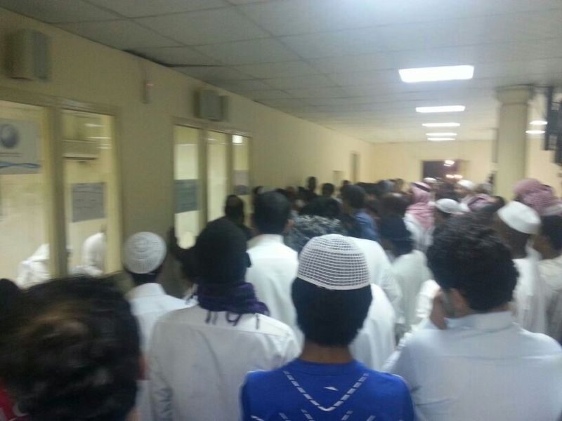

|Figure 1 Problem Definition|

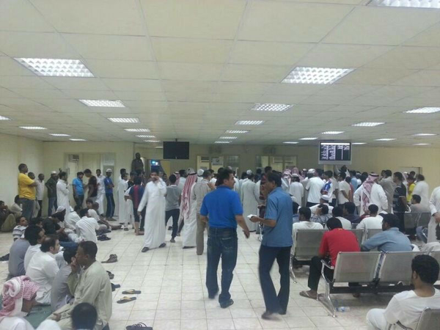

|Figure 2Problem Definition 2|

The above pictures talk about themselves, crowded people, and long queues waiting to get a water tanker for home consumption!!!.

# Current Situation

The current situation is run by classical methods which is to go to the physical location of the bulk tankers and make the order while our application will do all the needed process through electronic application. 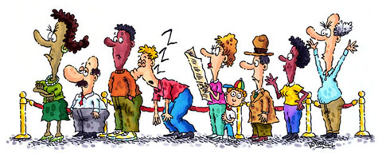

|Figure 3 Current Situation|

# Aims

* The project is combined from two parts: Android and web Applications.
* Android Application where customers can make the order of supplying water tanker and deliver to customer location. (The location identified by customer).
* The system will control the way of payment.
* Web application to control and monitor the data, and to make an order for customer those who don’t have an Android application.
* The tankers, drivers, customers and scheduling will be under the administrative control.

# Project objectives

* We will build a web and Android applications.
* admin will be able to do the following jobs:
  + Manage tankers data.
  + Manage driver’s data.
  + Manage schedule’s data.
  + View reports.
* Client will be able to do the following jobs:
  + Make an order for required water quantity.
  + System will give delivery date and time for the client.
  + Client has to pay to driver the cost.
* Driver will be able to do the following jobs:
  + Deliver orders as scheduled.
  + Collect the cost from the client.
  + Close the order after delivery.

# Scope

The Bulk water tankers System is developed to manage the relationship between clients and water supply delivers therefor we will design web application contain all basic data such as tankers info, drivers, etc.

* Provide a service for clients and administrators to access their activity via the internet.
* Improve the service of supplying water without any more headaches.

# Suggested Solutions

* The system will cover all requirements needed to achieve the target; we studied the project requirements by collecting the information directly from the needs of customers.
* We will consequently analysis, design and then write code of the system.
* The system will be tested, implemented and hosted at www and Android.
* Build storage as a web application to provide a secure way of remotely storing important data with providing tools for managing products and organizing storage space.



|Figure 4 Suggestion Solution|

# How will it work?

|Figure 5 How it works|

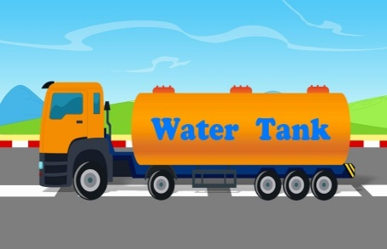

# Flow chart

Process

Start

End

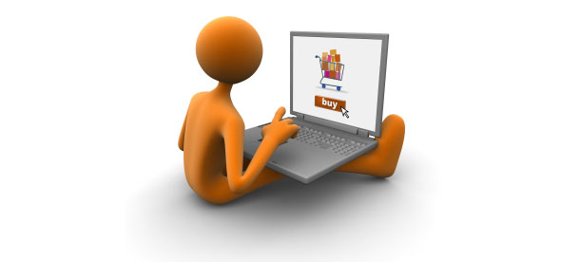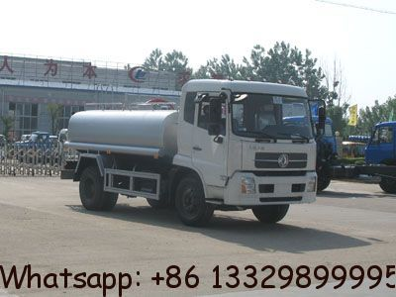

Select Tanker Size



System Calculate

Delivery time



prints list for

drivers

|Figure 6 Flow chart|

# What the committee will see at the end of our Project?

At the end of the project, we will have mobile (Android) application as well as a web application to serve clients who need water to be delivered to their location, the client can make the order, the driver will deliver the required tankers through the online order, and an admin will be able to manage the website.

 

# Key elements:

* Project Name: Bulk water delivery system
* Project Sponsor: public community
* Business need: public society need such project.
* Functionality: A fully implemented our system will help any society who has problems in water networks.

# Project stakeholders:

Admin: he is responsible for the system, view reports, enter tankers, drivers and schedules data and administrate the system.

Drivers: Deliver orders as scheduled, collect the cost from the client, and Close the order after delivery.

Client: Make an order for required water quantity and pay for driver the cost.

# Feasibility Analysis

# Objectives of a feasibility study:

* To find out if a system development project can be done.
* To suggest possible alternative solutions.

# Types of feasibility

# Technical feasibility

* Is the project possible with current technology?
* How much technical risk is there?
* Does the technology exist at all?
* Is it available locally?
* Can it be obtained?
* Will it be compatible with other systems?

The answer to the above questions is: the project is compatible with current technology because it is web and android application which has no risk and available at any time.

# Economic feasibility

* Is the project possible, given resource constraints?
* What benefits will result from the system?
* Both tangible and intangible benefits quantify them!
* What are the development and operational costs?
* Are the benefits worth the costs?

The answer to the above questions is: the project has no resource constraints and anyone can benefit but it is a little bit expensive because of android application.

# Schedule feasibility

* Is it possible to build a solution in time to be useful?
* Any constraints on the schedule?
* Can these constraints be met?

The answer to the above questions is: the project can be built within scheduled time.

# Operational feasibility

* If the system is developed, will it be used?
* Available of human resources?
* Potential labor objections?
* Manager resistance?
* Organizational conflicts and policies?
* Social acceptability?
* Legal aspects and government regulations?

The answer to the above questions is: the project can be used efficiently, it is compatible with regulations and policies of the government, and such project is welcome by the society.

# Schedule of events using Gantt chart.

**First Term (Project 1):**

Start Date: Sept 1, 2015

End Date: Dec 4, 2015

**Second Term (Project 2):**

Start Date: Jan 25, 2016

End Date: May 19, 2016

Table 1 Task duration

|  |  |  |  |  |
| --- | --- | --- | --- | --- |
| Task Name | Duration | Start | Finish |  |
| Collecting Information | 11 days? | T 15/09/01 | T 15/09/15 |  |
| Introduction | 3 days | T 15/09/01 | T 15/09/03 | Introduction |
| Problem Definition | 3 days | F 15/09/04 | T 15/09/08 |
| Scope | 2 days | W 15/09/09 | T 15/09/10 |
| Suggested solution | 1 day | F 15/09/11 | F 15/09/11 |
| Key Elements | 1 day? | M 15/09/14 | M 15/09/14 |
| feasibility study | 1 day | T 15/09/15 | T 15/09/15 |
| Project Plan | 3 days | W 15/09/16 | F 15/09/18 | Project Plan |
| Time Plan | 2 days | W 15/09/16 | T 15/09/17 |
| Schedule | 1 day | F 15/09/18 | F 15/09/18 |
| Literature Review | 11 days? | M 15/09/21 | M 15/10/05 |  |
| Literature Review | 3 days | M 15/09/21 | W 15/09/23 | Literature Survey |
| References | 1 day | T 15/09/24 | T 15/09/24 |
| Hardware and Software Listing | 1 day? | F 15/09/25 | F 15/09/25 |
| References | 1 day? | M 15/09/28 | M 15/09/28 |
| Submit First Report | 5 days | T 15/09/29 | M 15/10/05 |
| Analysis And Design | 18 days | T 15/10/06 | T 15/10/29 | **Analysis And Design** |
| Overview Previous Work | 3 days | T 15/10/06 | T 15/10/08 |
| System Actors Specifications | 4 days | F 15/10/09 | W 15/10/14 |
| Use Case Diagram | 3 days | T 15/10/15 | M 15/10/19 |
| Functional Requirement | 2 days | T 15/10/20 | W 15/10/21 |
| Non Functional Requirement | 2 days | T 15/10/22 | F 15/10/23 |
| Database Requirement | 2 days | M 15/10/26 | T 15/10/27 |
| Flow Chart | 2 days | W 15/10/28 | T 15/10/29 |
| Methodologies | 25 days | F 15/10/30 | T 15/12/03 | **Methodologies** |
| ER Diagram | 3 days | F 15/10/30 | T 15/11/03 |
| Methodology | 3 days | W 15/11/04 | F 15/11/06 |
| Sequence Diagram | 2 days | M 15/11/09 | T 15/11/10 |
| Class Diagram | 2 days | W 15/11/11 | T 15/11/12 |
| Interface Design | 4 days | F 15/11/13 | W 15/11/18 |
| Documentation | 10 days | T 15/11/19 | W 15/12/02 |
| Submitting Final Report | 1 day | T 15/12/03 | T 15/12/03 |
| System Implementation | 71 days | M 16/01/25 | M 16/05/02 | Implementation |
| Overview Previous Work | 5 days | M 16/01/25 | F 16/01/29 |
| Implementation of Database | 6 days | M 16/02/01 | M 16/02/08 |
| Prototype | 10 days | T 16/02/09 | M 16/02/22 |
| Code writing | 40 days | T 16/02/23 | M 16/04/18 |
| Testing | 5 days | T 16/04/19 | M 16/04/25 |
| Fixing Bugs | 5 days | T 16/04/26 | M 16/05/02 |
| Deployment | 13 days | T 16/05/03 | T 16/05/19 | **Deployment** |
| Documentation | 6 days | T 16/05/03 | T 16/05/10 |
| Submitting Final Report | 4 days | W 16/05/11 | M 16/05/16 |
| Discussing Final project | 3 days | T 16/05/17 | T 16/05/19 |

Table 2(MSP)

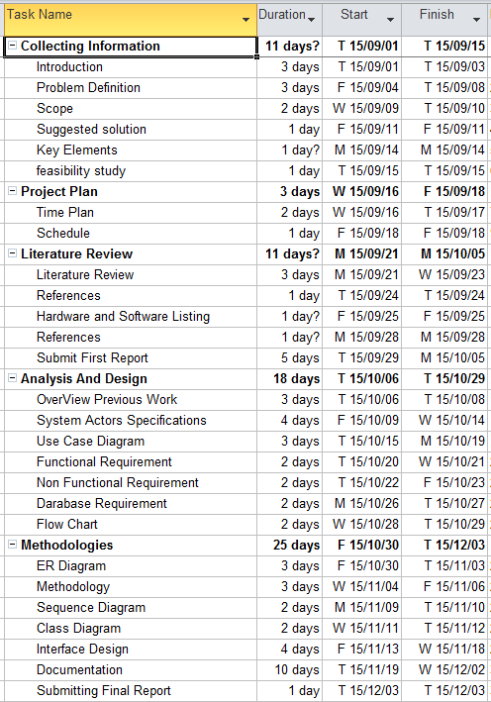

Table 3(MSP)

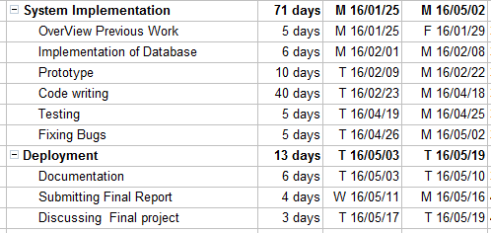

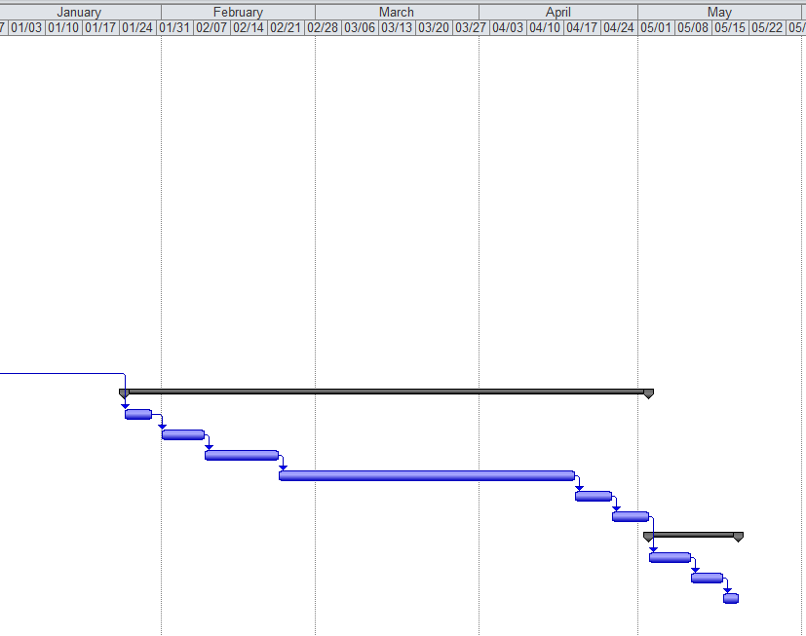

|Figure 7 Gantt Chart 1|

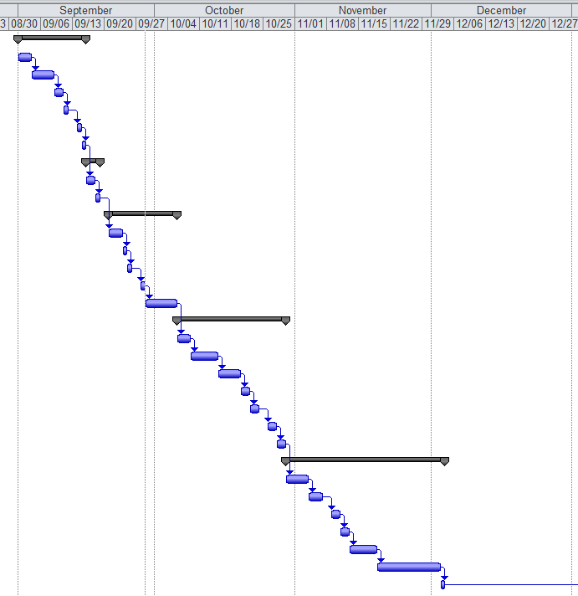

|Figure 8 Gantt Chart2|

# Tools and software

* Visual Studio software 2010 (C#.net, ASP.net): Programming Language



* SQL Server 2008 for Database: Storing the data in tables

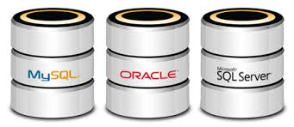

* Microsoft Office 2010: such as Word, power point
* Microsoft Project software: planning for project

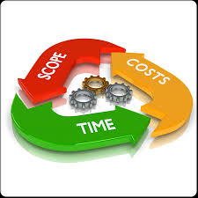

* Mobile Working on an Android system. Software used for application:



* Eclipse: is an open source software applications using Java.
* Java standard edition (Java SE): Java is a software package for the development of Android applications as it contains the JDK and JRE.
* Android SDK (Android Software Development kit): Assist to provide libraries and tools contribute to development and test the applications on the Android platform.16.

# Contributions

We work as a group in the whole project, everything we made it together.

# Summary of changes

|  |  |  |
| --- | --- | --- |
| Supervisor | Action Taken | Reason for changes |
| Dr.Muttasm jarrah | One of our features (Display The Waiting Time) To Scheduling orders (the user will select the data and time) | Depends on our survey analysis (user requirements) |
| Dr.Muttasm jarrah | Grammatical modification | Make our report more logical and readable. |

# Chapter 2

# Literature Survey

# Preparing for literature search:

To look for literature survey, we have to go through different resources such as books, articles, websites, and search engines (ex. google search engine).

We found an article talking about delivering safe water by tankers written by UNICEF. For more details we can refer to this link:

<http://www.unicef.org/cholera/Annexes/Supporting_Resources/Annex_9/WHO-tn12_safe_water_tanker_en.pdf>.

It is technical notes on drinking water, sanitation and hygiene in emergencies.

We searched for water tanker in google search engine we have chosen the following websites which are very much similar to our objective.

# Sources Used in the Literature

# Water Supply Systems and Evaluation Methods Service

This article is written by Harry E. Hickey, Ph.D. under the title Water Supply System Concepts, covering many areas about water supply, he started by fundamental considerations; continuous availability, water resources, classification of water systems, then he talked about many things but what is relevant to our project is alternative water supplies whereas he wrote about the water delivery program and concentrated on the points of filling the tanker and time consideration in case of fire.[4]

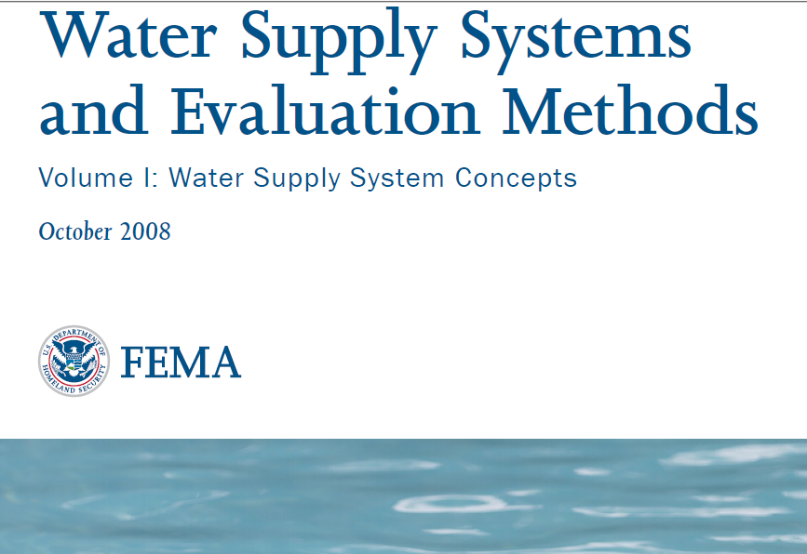

|  |  |
| --- | --- |
| **PROMPT criteria** | **Evaluation** |
| **Presentation** | It is presented as pdf file talk water supply system concepts, dividing the article into chapters which is easy to follow and find the piece of information you need. |
| **Relevance** | It is about methods of delivery, quality and purpose. |
| **Difference** | * We will use google map to locate the customer position and calculate approximate distance and time of delivery. * He concentrated on the supply of water for firefighting purposes. |
| **Method** | The author made a study of the concepts of water supplies writing about all possible alternatives. |
| **Provenance** | It is done under the supervision of U.S. Fire Administration. |
| **Timeliness** | Article written on October 2008. |

# Drinking Water Tanker Service

Summary: We benefited from this website how to make order and contact process.

This website is designed to deliver water to houses, offices and work locations, the website gives the prices and the way of delivery. [1]

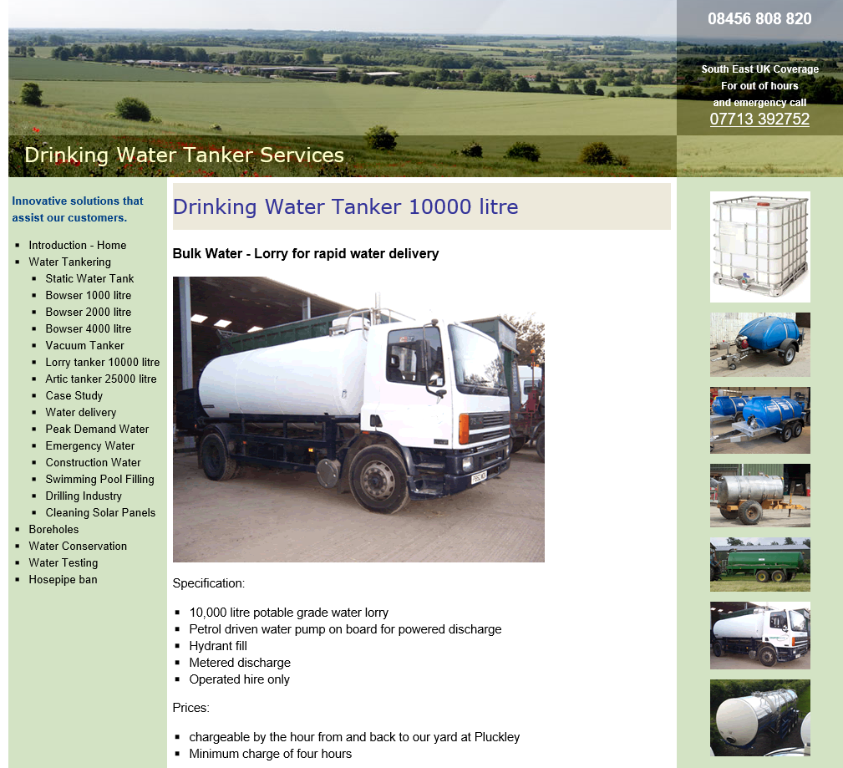

|Figure 9 Drinking Water Tanker Service|

|  |  |
| --- | --- |
| **PROMPT criteria** | **Evaluation** |
| **Presentation** | It is good looking and well-presented, you can read the instruction, make order and payment in the same page. |
| **Relevance** | It is too much close to our project which support the following functions:   * It is drinking water system. * Make online order. |
| **Difference** | We will use google map to locate the customer position and calculate approximate distance and time of delivery. |
| **Method** | This is website, it has no references, but we can judge that the analyst studied the requirements well and decided to design the site in this way. |
| **Provenance** | This website is trusted because this website belongs to a reputed organization. |
| **Timeliness** | This website is still online. Oct 2015 |

# Clean Pool and Spa

Summary: This is designed to deliver water mainly to swimming pools, but it is also to clients such as farms, hospitals, residential drinking water and so on.[2]

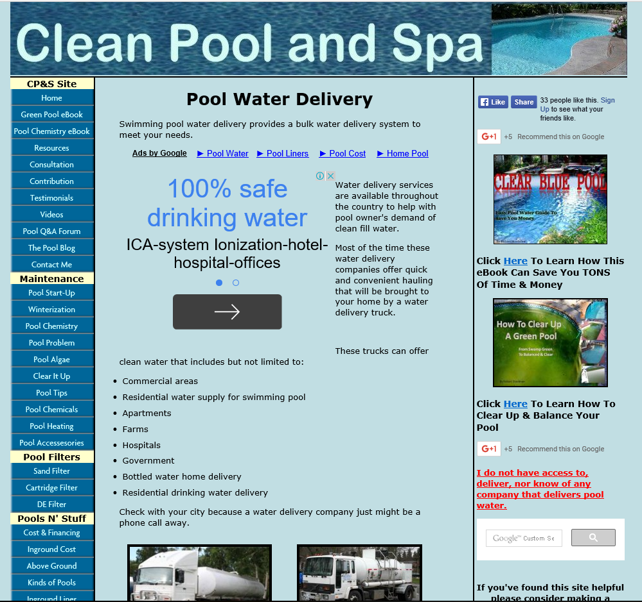

|Figure 10 Clean Pool and Spa|

|  |  |
| --- | --- |
| **PROMPT criteria** | **Evaluation** |
| **Presentation** | It is well-presented, menus talk about themselves, and you can read the areas of interests from the first glance. |
| **Relevance** | In spite of the main title (Clean Pool) but it is also for other activities such as farms, hospitals etc. we share only delivery water tanker. |
| **Difference** | * We will use google map to locate the customer position and calculate approximate distance and time of delivery. * It has other activities such as consultation. |
| **Method** | It is initiative from one person – Robert – who says about himself *“*Yes, this is it, the "About Me' page. I've always been interested in swimming pool care but I never had an outlet to say what I wanted to say, until now. So here it goes”. |
| **Provenance** | This website is trusted because this website is informative more than service and the information are useful. |
| **Timeliness** | This website is still online. Oct 2015 |

# Water Direct

Summary: This website is to serve three categories: bottled water, drinking water tanks and bulk water tankers.

It is also for emergency cases and uses fast tanker delivery. [3]

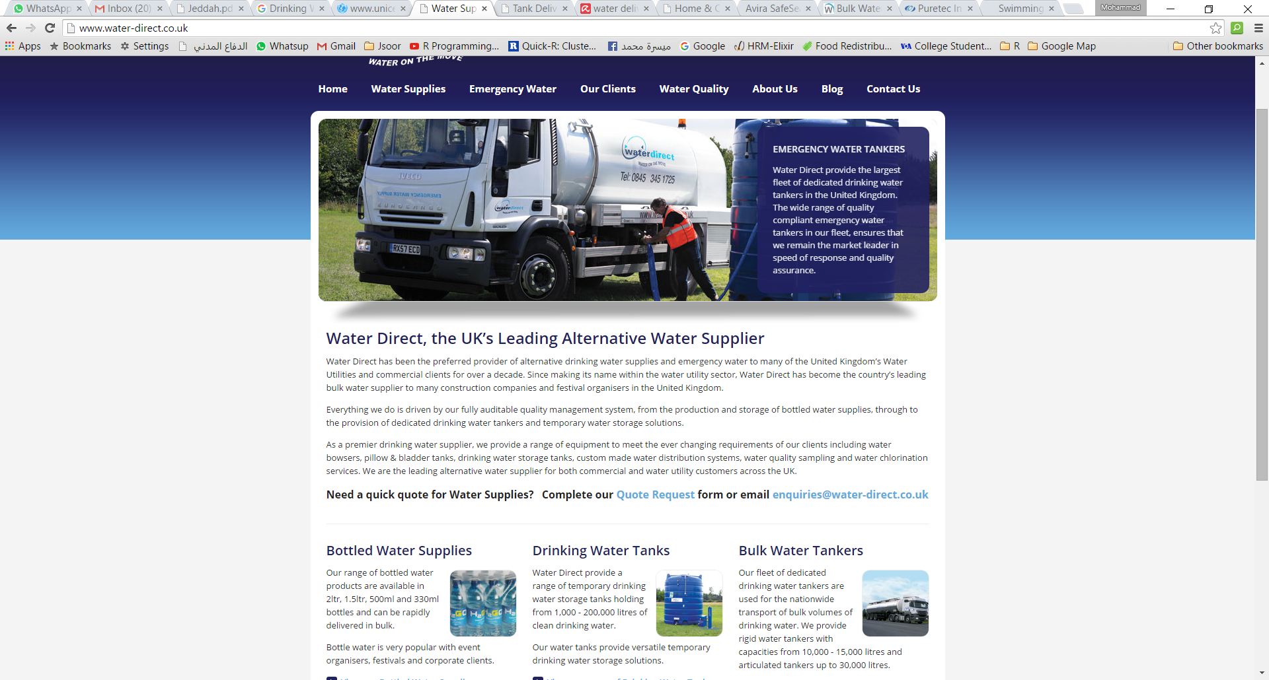

Figure 11 Water Direct

|  |  |
| --- | --- |
| **PROMPT criteria** | **Evaluation** |
| **Presentation** | The layout of the website is divided into sections according to activity, it is easy to follow. |
| **Relevance** | It has three activities: bottled water, drinking water tanks and bulk water tankers. We share only bulk water tankers. |
| **Difference** | * We will use google map to locate the customer position and calculate approximate distance and time of delivery. * It has other activities: bottled water, drinking water tanks and bulk water tankers. |
| **Method** | Water Direct, the service and name, were conceived in 1996 and has become synonymous with quality assured alternative drinking water supplies primarily for the Water Utility sector. |
| **Provenance** | Multi task website which provides a several of the activities. |
| **Timeliness** | This website is still online. Oct 2015 |

# Liquiline Event Water Service

Summary: This website is about water tanker hire for short and long terms as well as a water tanker with special specification. [6]

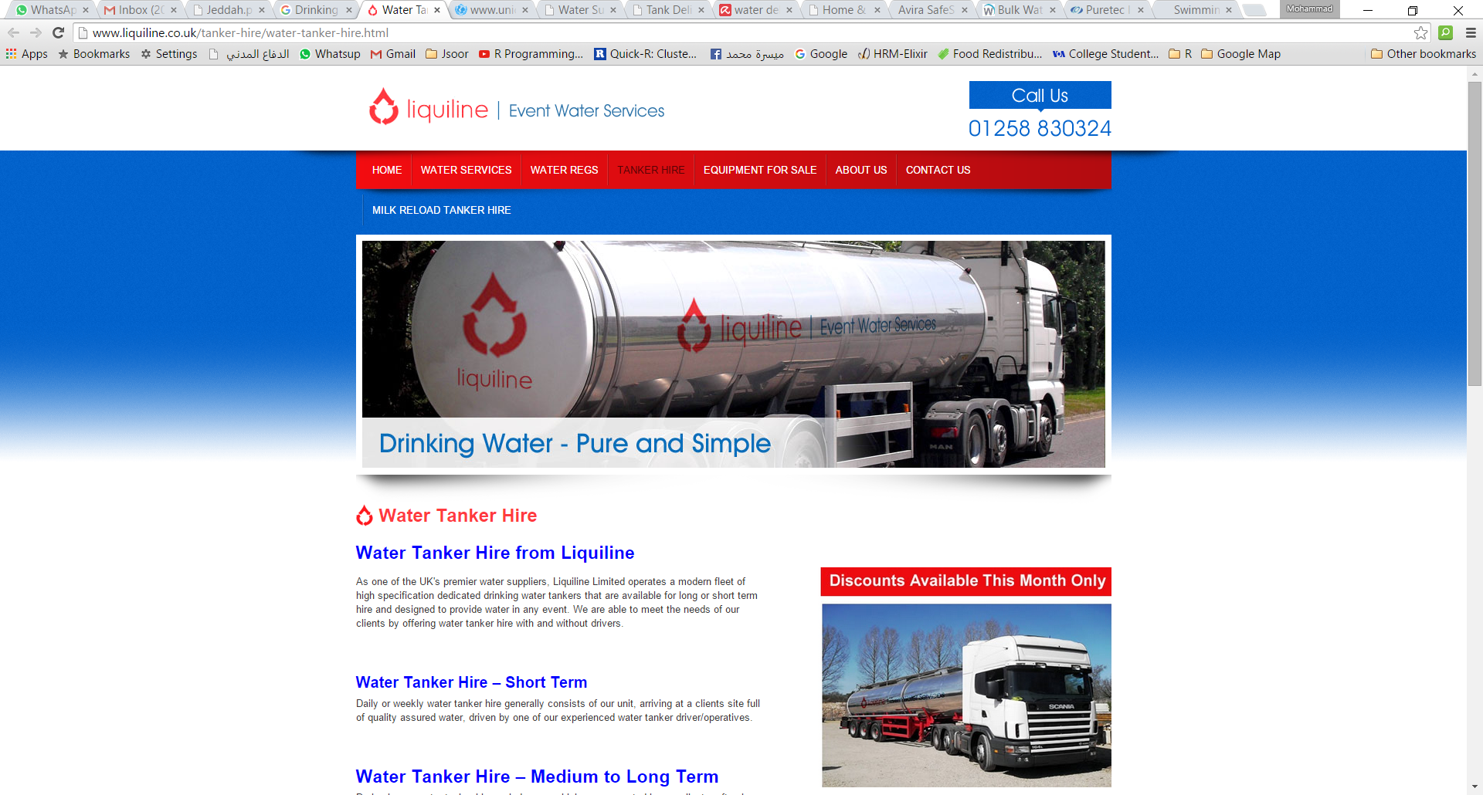

|Figure 12 :Liquiline|

|  |  |
| --- | --- |
| **PROMPT criteria** | **Evaluation** |
| **Presentation** | It is categorized and the layout very easy to follow. The language is clear and the paragraphs are spaced to distinguish between the activities. |
| **Relevance** | We can benefit from this website by studying the way they hire the tankers. |
| **Difference** | * We will use google map to locate the customer position and calculate approximate distance and time of delivery. * It is hiring tankers. |
| **Method** | We have no reference to the method used. |
| **Provenance** | Multi task website which provides a several of the activities. |
| **Timeliness** | This website is still online. Oct 2015 |

# Pure Tec Industrial Water

Summary: This website is a traditional way of online orders, customer has to create an account and to pay in advance by visa card. [5]

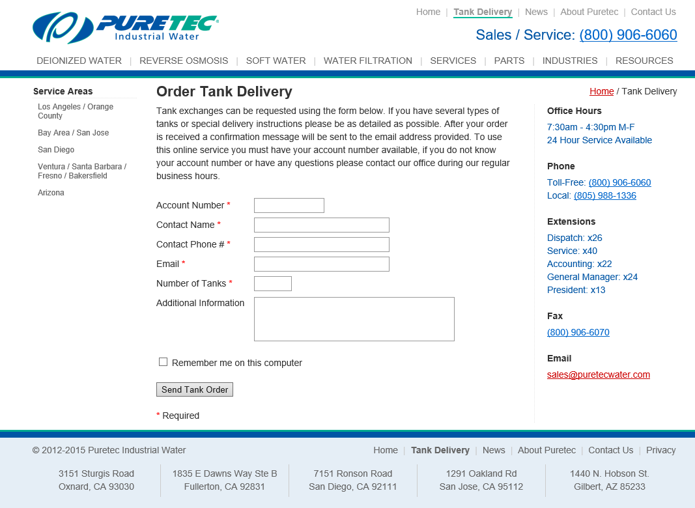

Figure 13 PureTEC

|  |  |
| --- | --- |
| **PROMPT criteria** | **Evaluation** |
| **Presentation** | It is simple and well-presented, you can read the instruction, make an order but it is not clear how to pay. |
| **Relevance** | It is not close to our project because   * It is about tanks. * Make online order. |
| **Difference** | We will use google map to locate the customer position and calculate approximate distance and time of delivery. |
| **Objectivity** | The site meets the aim built for, the website is designed in several sizes or tanks. It is trustful. |
| **Method** | This is website, it has no references, but we can judge that the analyst studied the requirements well and decided to design the site in this way. |
| **Provenance** | This website is trusted because this website belongs to a reputed organization. |
| **Timeliness** | This website is still online. Oct 2015 |

# Chapter 3 Analysis and Design

# Requirements gathering

We select the survey to collect our requirements

* Survey analysis :

### Q1. Do you think website solve the problem?

The static of the questionnaire shows that 64% of the people think the system will solve the problem of the water tanker. From this we can see the importance of our project to the so**c**iety.

### C:\Users\1207730\Desktop\Capturehjk.PNG

|  |  |  |
| --- | --- | --- |
| 1. Yes, sure it will solve. | 64% | |
| 1. No, it will not solve. | 20.2% |
| 1. It may solve. | 15.8% |

Q2. Which method do you prefer when you make an order?

another percentage shows us that 86.7% of the people want to select the date and time which the tanker will arrive .This made a change in our mind  ,because we mentioned before we will put a waiting time  , but now we will change it in cpit499 and make it as scheduling .

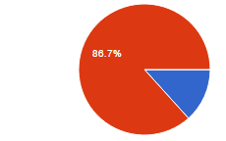

1. Show waiting time. (The system will show you when the tanker could arrive) 13.3%.
2. scheduling the date and time ( the customer select the date and time he wants) 86.7%
3. Other.

# Functional Requirements

|  |  |
| --- | --- |
| Manage Tanker | |
| Actor | Admin |
| Description | Admin will be able to manage tankers data. |
| Priority | Normal |
| Requirements | 1. Database to store tanker information. 2. User friendly interface |

|  |  |
| --- | --- |
| Make order | |
| Actor | Customer |
| Description | Customer will be able to make order for required water tanker. |
| Priority | Normal |
| Requirements | 1. Database to store order information. 2. User friendly interface |

|  |  |
| --- | --- |
| Delete the order | |
| Actor | Admin |
| Description | Admin will be able to Delete the order after take the money. |
| Priority | Normal |
| Requirements | 1. Database to store order information. 2. User friendly interface |

|  |  |
| --- | --- |
| Payment | |
| Actor | Customer |
| Description | Customer has to ways to pay (cash or by the system) |
| Priority | Normal |
| Requirements | 1. Database to store payment information. 2. User friendly interface |

# Non-functional requirements

|  |  |
| --- | --- |
| **Usability** | |
| Description | Must be user interface easy so as to provide better results in terms of language, font size, colour and other important issues in system design, we will use CSS as theme for all project. |
| Priority | Medium |
| Requirements | * Design CSS. |

|  |  |
| --- | --- |
| **Performance** | |
| Description | Depends on devices, the users, and the system supports web applications. System must run at any time. |
| Priority | Medium |
| Requirements | * Modern servers. * Good internet connection. |

|  |  |
| --- | --- |
| **Security** | |
| Description | When you record your password should be password numbers and Characters to be the strongest protection. When entering and must be password in the Stars (***) to avoid theft.  We need back up for database |
| Priority | High |
| Requirements | * Ensure choosing strong password * Ensure good firewall. * Close all ports except the necessary one. |

# Data requirements

Our system has the following data requirements:

* + - * Customer Data.
      * Order Data.
      * Administrators Data.
      * Tankers Data.

# Project actors

1-Admin: he is responsible for the system, manage tankers and orders.

2- customer: Make order for required water tanker.

# Use case diagram

# C:\Users\1207730\AppData\Local\Microsoft\Windows\INetCache\Content.Word\Water.jpg

Figure 14

Use case description:

1. Make order

Actor: Customer

Description: Customer will be able to select tanker type and the date and time. Also he can pay from the system or cash.

1. manage the order

Actor: Admin

Description: Admin will be able to manage the order after take the money (deleting or conforming the order)

1. Manage Tanker

Actor: Admin

Description: Admin will be able to manage tankers data. (Delete, update and add)

# Use case traceability matrix

|  |  |  |  |  |  |  |  |
| --- | --- | --- | --- | --- | --- | --- | --- |
|  | Register | Make order | pay | View orders | View profile | Delete orders | Manage tankers |
| Manage tankers |  |  |  |  |  |  | ✓ |
| Delete orders |  |  |  |  |  | ✓ |  |
| Pay |  |  | ✓ |  |  |  |  |
| Make orders |  | ✓ |  |  |  |  |  |

# Chapter 4 Methodology

# Methodology used

Extreme programming (XP):

1- XP is set up for small groups of programmers. Between 2 and 12.

2- Of all the agile methods, XP is the only method that provides deep and profound disciplines for the way developers do their daily work.

3- One of the major advantages of Extreme Programming is that it reduces the risks related to programming. Conventional programming depends a lot on individual ‘superstars’ or critical members in the team. Extreme Programming, by breaking the tasks into modules.

# Tools

1- Star UML.

2- Microsoft Visio.

# Sequence diagrams

# 

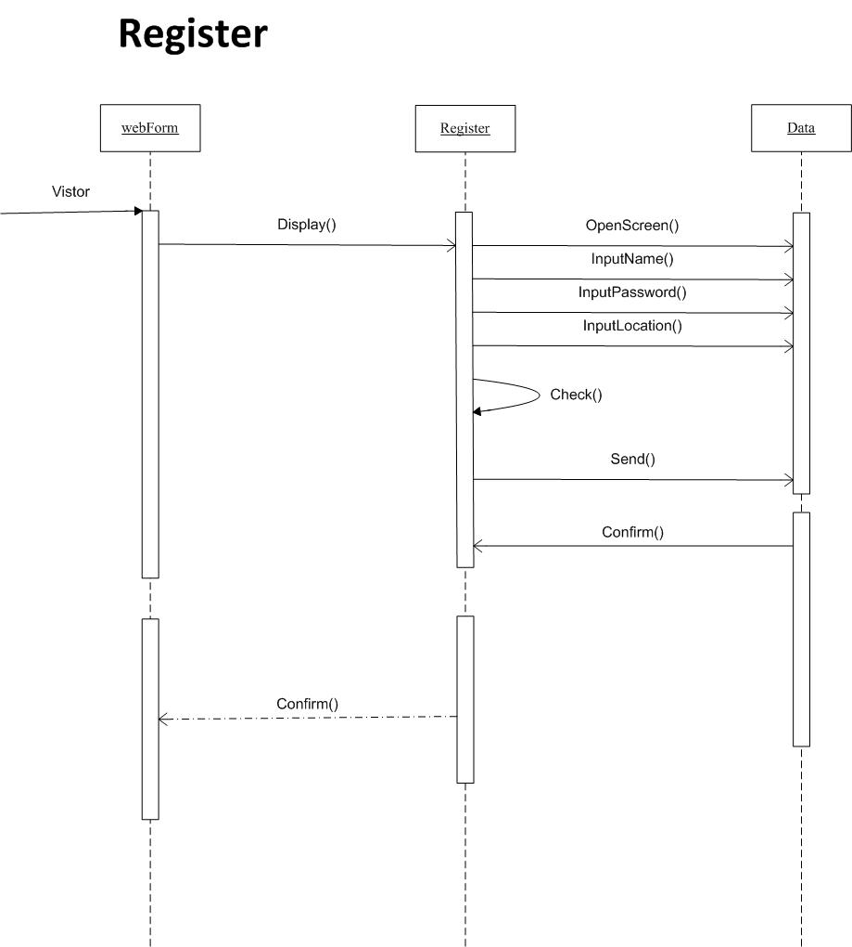

Figure 15

# 

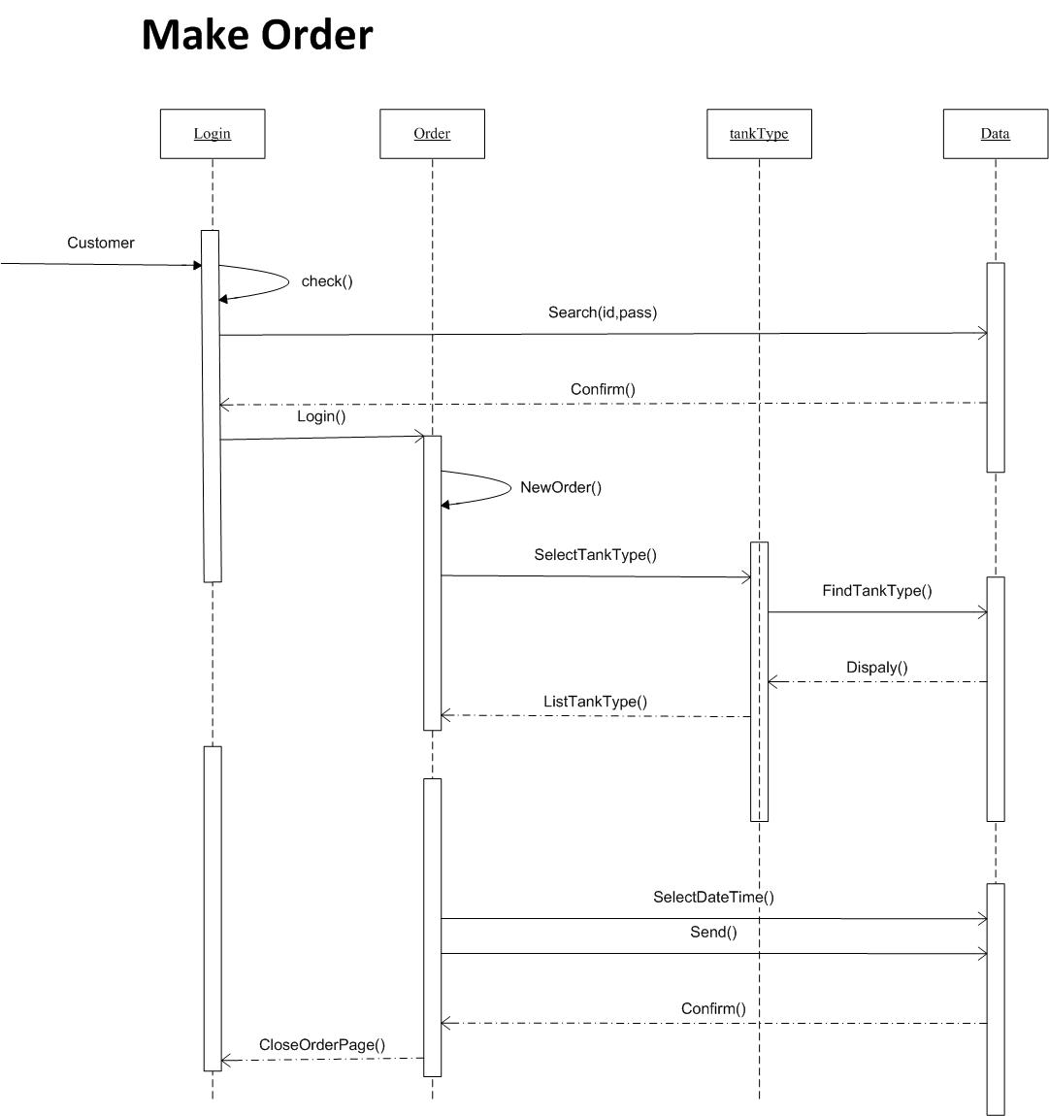

Figure 16

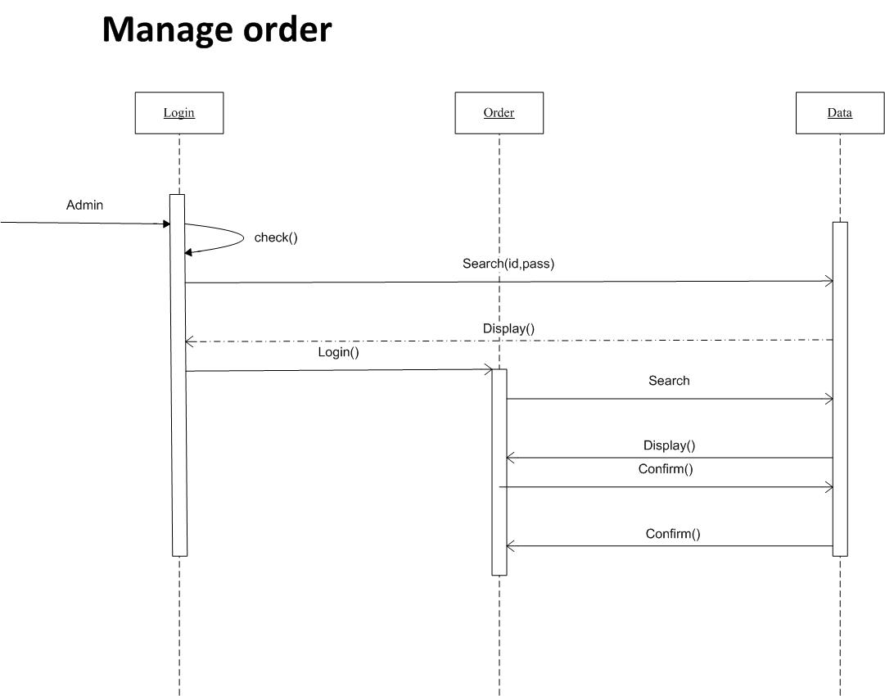

Figure 17

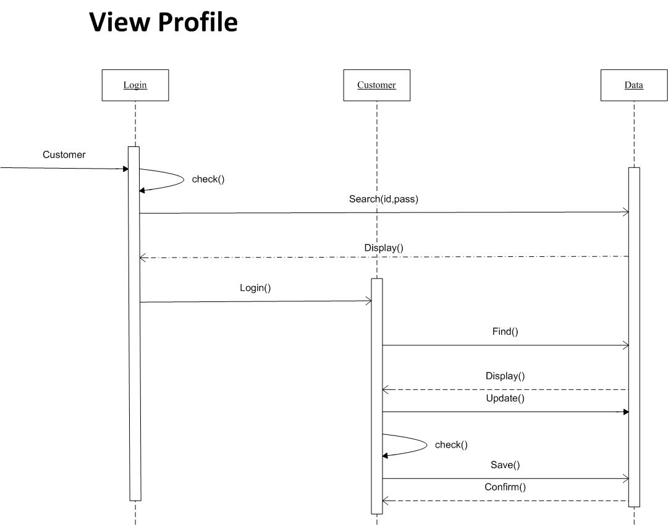

Figure 18

# Class diagram

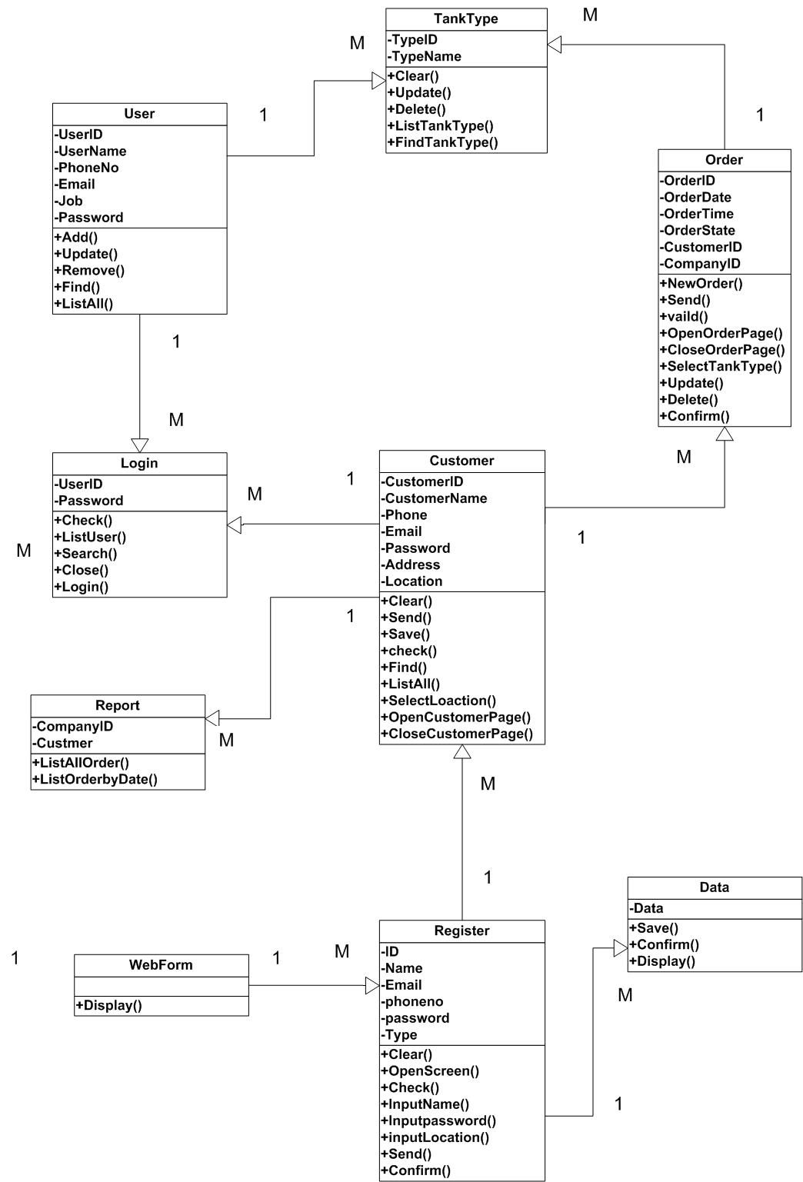

Figure 19

# Database schema

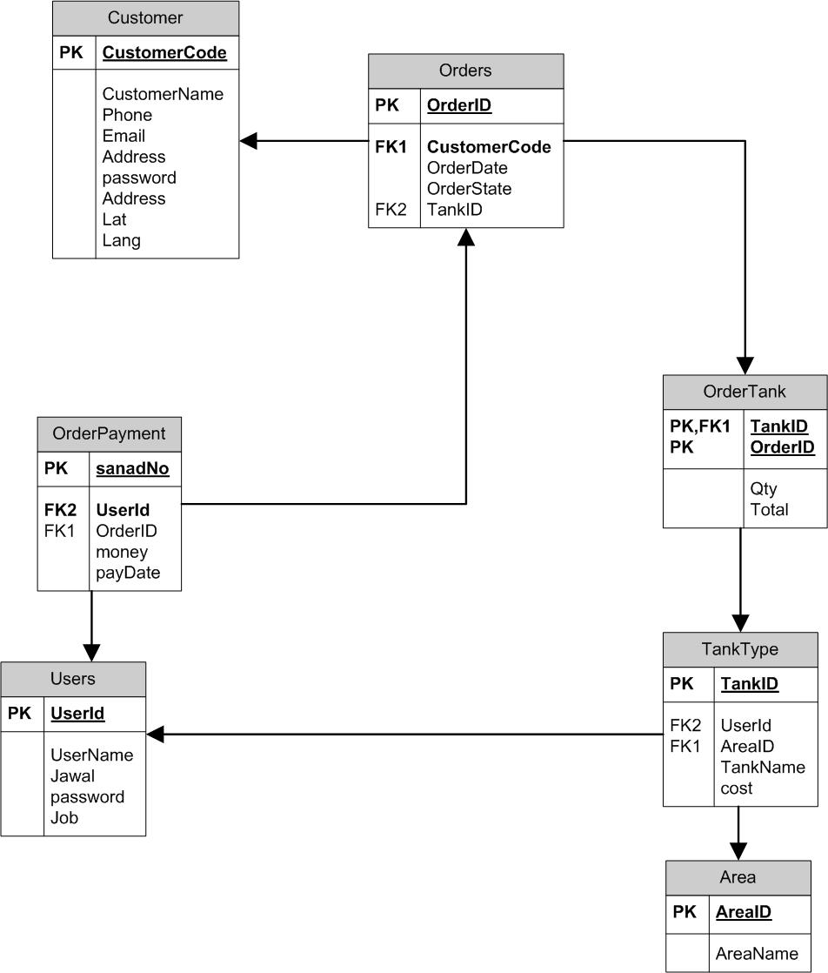

Figure 20

# Chapter 5 Interfaces

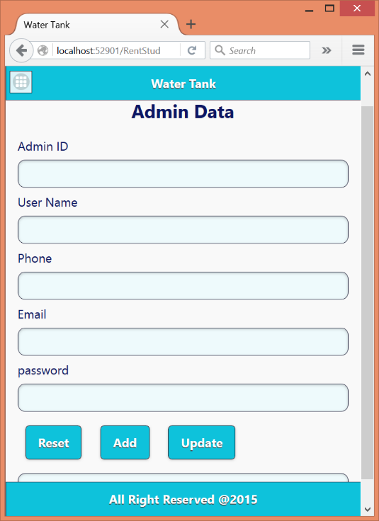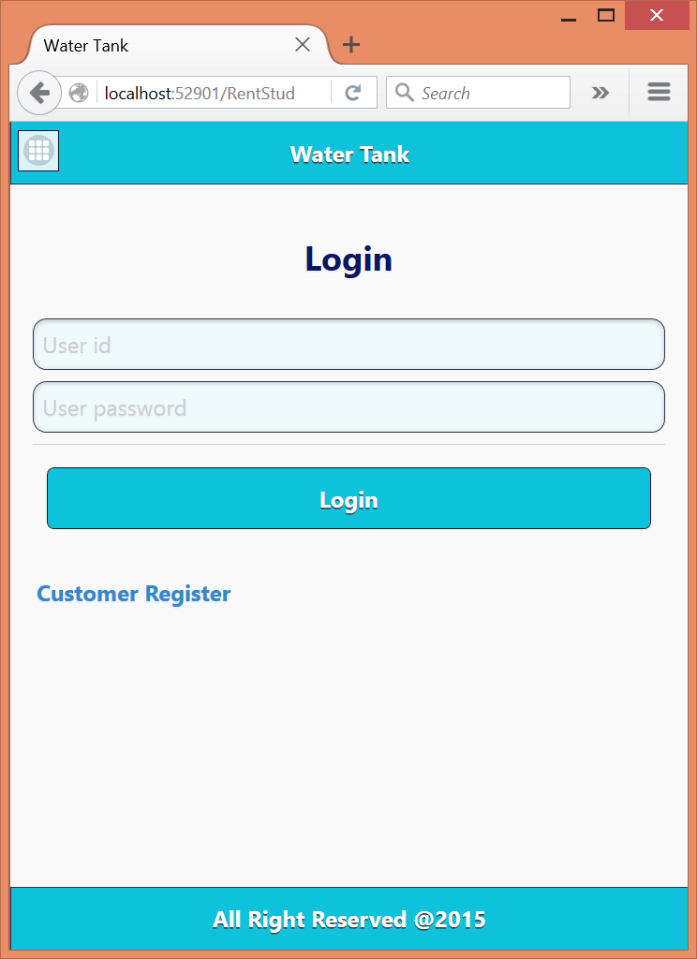

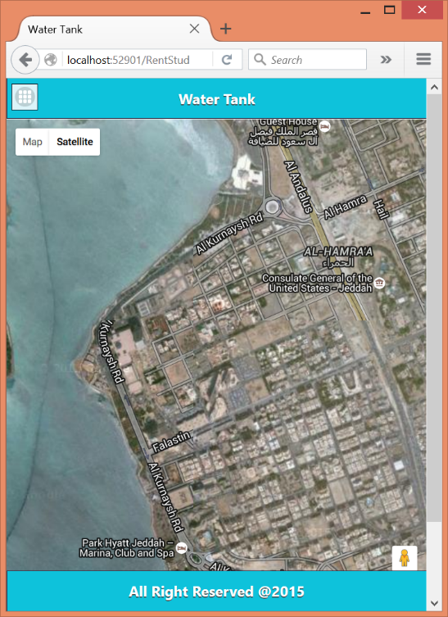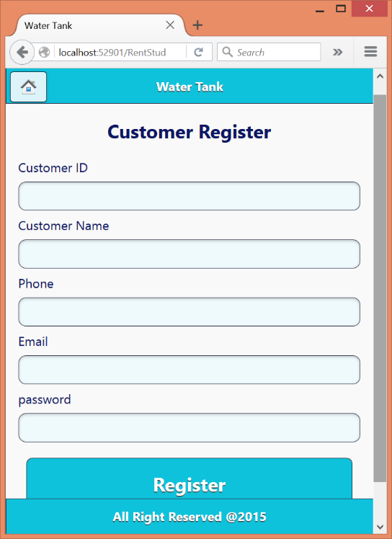

# Bibliography

(n.d.). Retrieved from Water Tanker Delivery: http://www.emergencywaterservice.co.uk/water%20tanker/water%20tanker%20delivery.asp

(n.d.). Retrieved from Clean Pool Spa: http://www.clean-pool-and-spa.com/pool-water-delivery.html

(n.d.). Retrieved from Water Direct: http://www.water-direct.co.uk/.

Harry E. Hickey, P. (2008, October). Water Supply Systems and Evaluation Methods. *Water Supply System Concepts*, p. https://www.usfa.fema.gov/downloads/pdf/publications/water_supply_systems_volume_i.pdf.

*Tank Delivery*. (n.d.). Retrieved from Pure Tec Water: http://puretecwater.com/tank-delivery.html.

*Tanker Hire*. (n.d.). Retrieved from Liquiline: http://www.liquiline.co.uk/tanker-hire/water-tanker-hire.html.

UNICEF. (2010). UNICEF ORGANIZATION. http://www.unicef.org/cholera/Annexes/Supporting_Resources/Annex_9/WHO-tn12_safe_water_tanker_en.pdf.

Appendix:

1. How do you overcome the problem of water shortage?
   1. Wait until water is pumped from source.
   2. Order water tanker from market.
   3. Other.
2. Do you think buying water tanker is suitable way to solve this problem?
   1. Yes, it is suitable.
   2. No, it is not suitable.
   3. It is sometimes suitable.
3. When you need tanker you :
   1. Go to tanker location and stand in queue.
   2. You order by telephone.
   3. Other.
4. Do you use any media?
   1. To deliver water.
   2. I do not use any media.
   3. I do know.
5. Do you think website solve the problem?
   1. Yes, sure it will solve.
   2. No, it will not solve.
   3. It may solve.
6. Do you think an official authority should adopt this project?
   1. Yes, I think so.
   2. No, not necessary.
   3. Private sector should operate such project in order to insure it will succeed
7. Do you think it is safe and trustful way to use website to organize for water tanker process?
   1. Yes, I think so.
   2. No, I don’t think so.
   3. I don’t know.
8. Do you think such website should be for only one area?
   1. It should be only for one area.
   2. It can be for all areas.
   3. It does not matter.

1. Do we need to make public education so that people would accept such website?
   1. Yes, we need.
   2. No, we do not need because people got used for this technology.
   3. We need but not much.
2. Which method do you prefer when you make an order:
   1. Show waiting time. ( the system will show you when the tanker could arrive )
   2. scheduling the date and time ( the customer select the date and time he wants)
   3. Other